**Sunkari Manohar**

**Assessment 5 – 03/01/2024**

**Azure databricks**

Today we created storage account in azure portal and we accessed that storage account in Microsoft azure storage explorer.

First we need to search for storage accounts in azure portal.

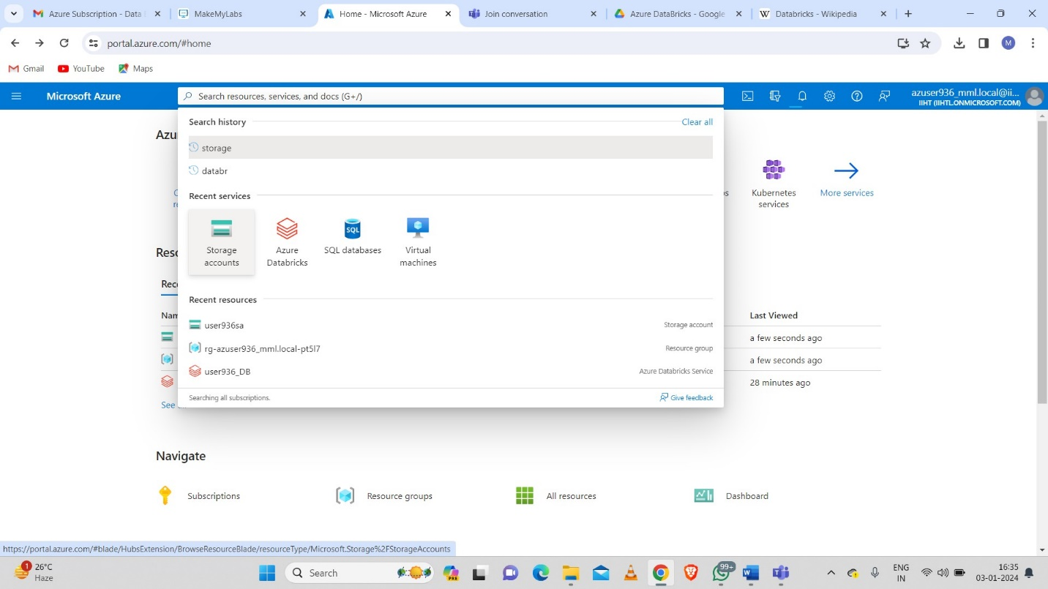

After clicking on storage accounts we need to create a storage account using “create” option.

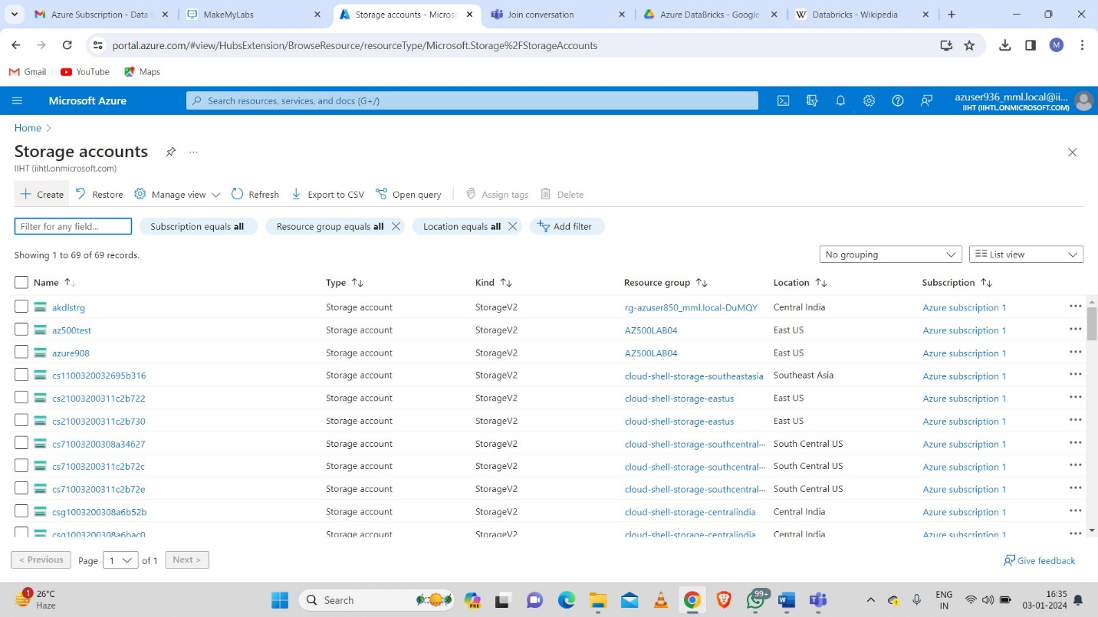

After that we need to select the resource group in which we want to create a storage account and name of storage account.

And we need to enable hierarchial namespace in advanced and we need to review the details and then clicking on create button to create storage account.

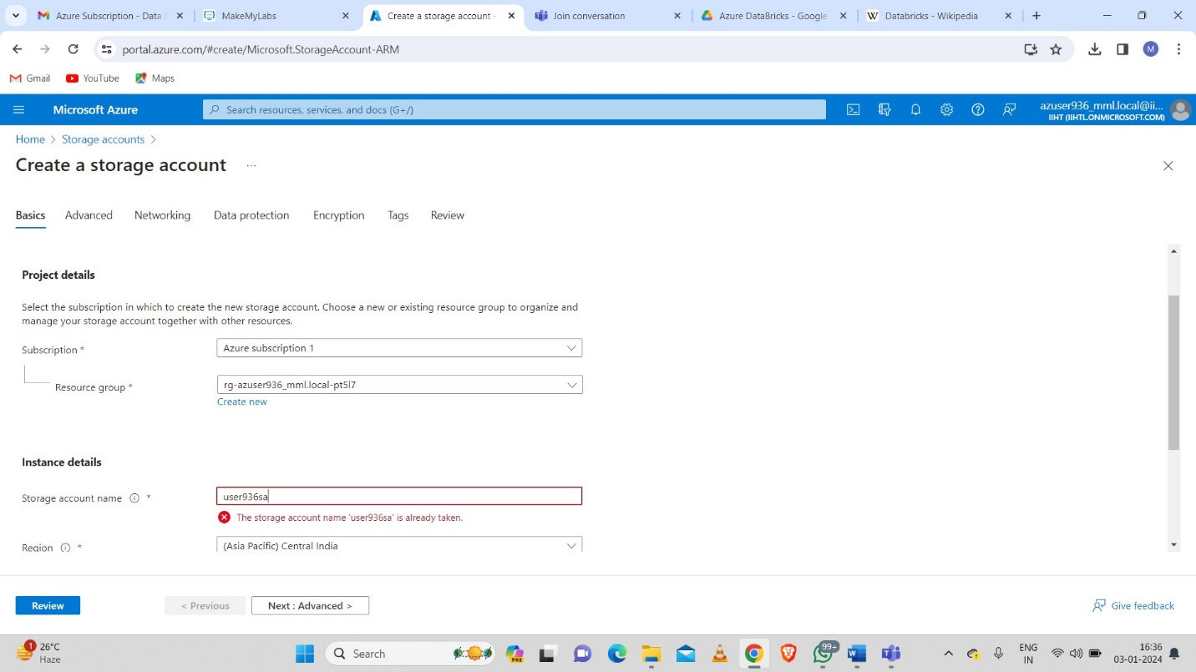

Deployment of storage account.

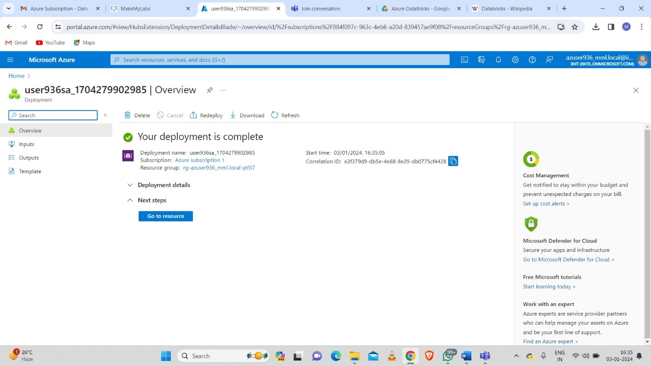

In azure portal we need to open our storage account we need to create a container to create or upload data.

And uploaded one file in the container.

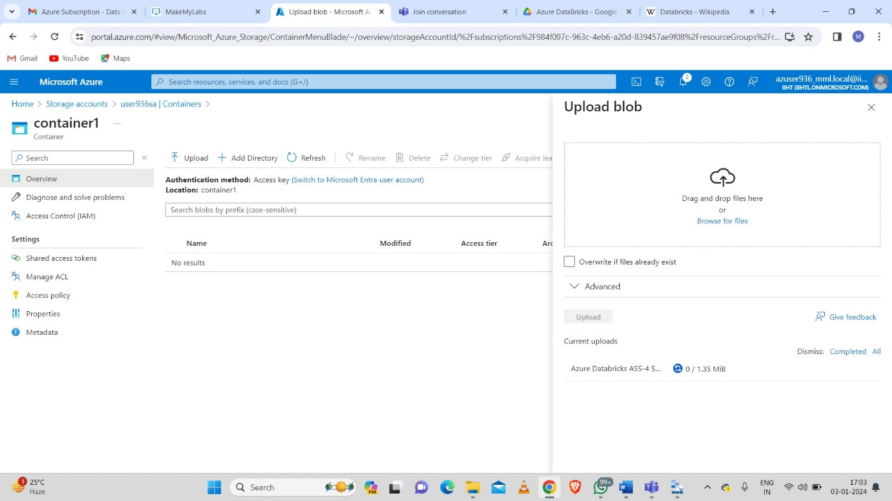

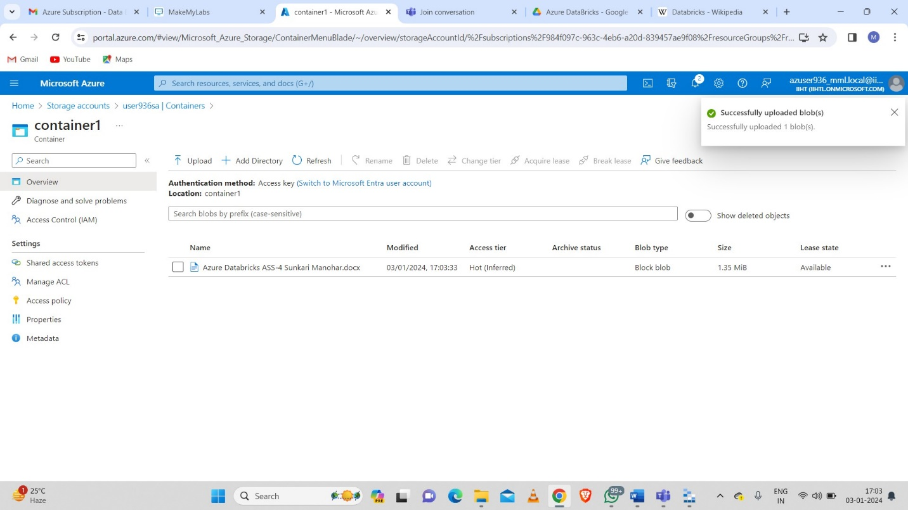

After creation we need to install azure storage explorer and we need to sign in with azure.

After clicking sign in with azure it will redirected to browser and ask us to sign in.

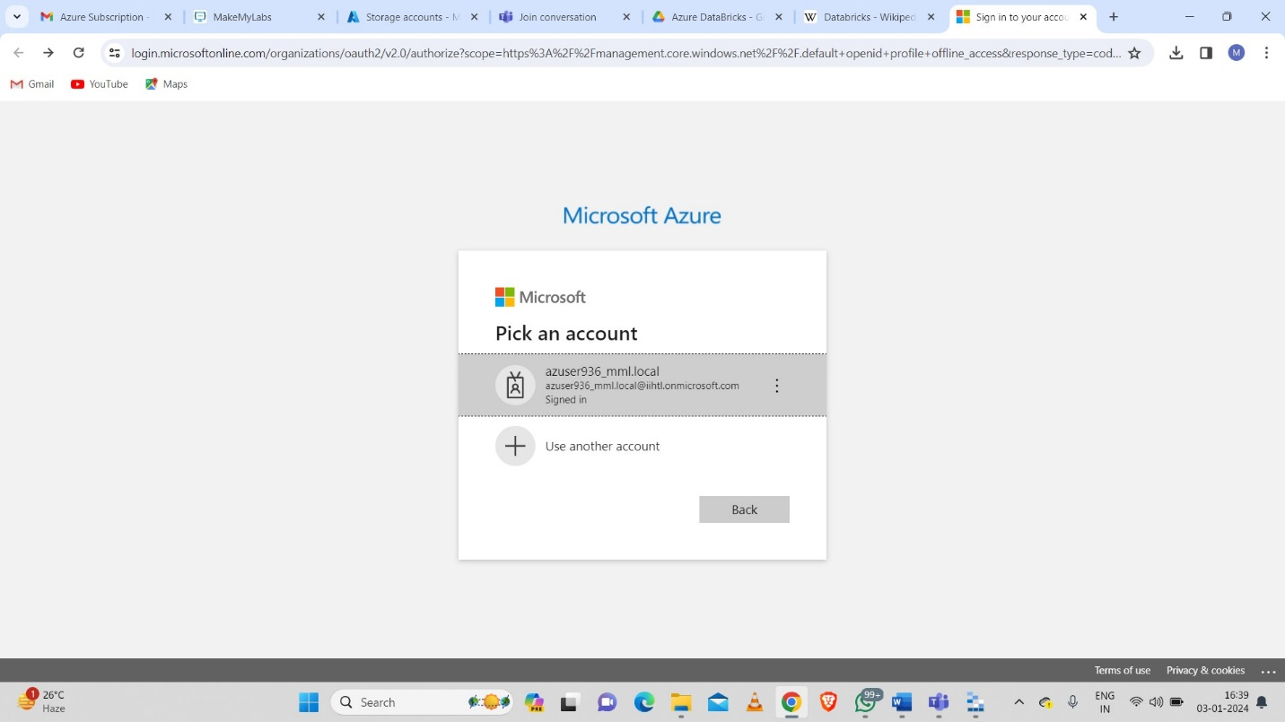

Then azure account will be added to the explorer.

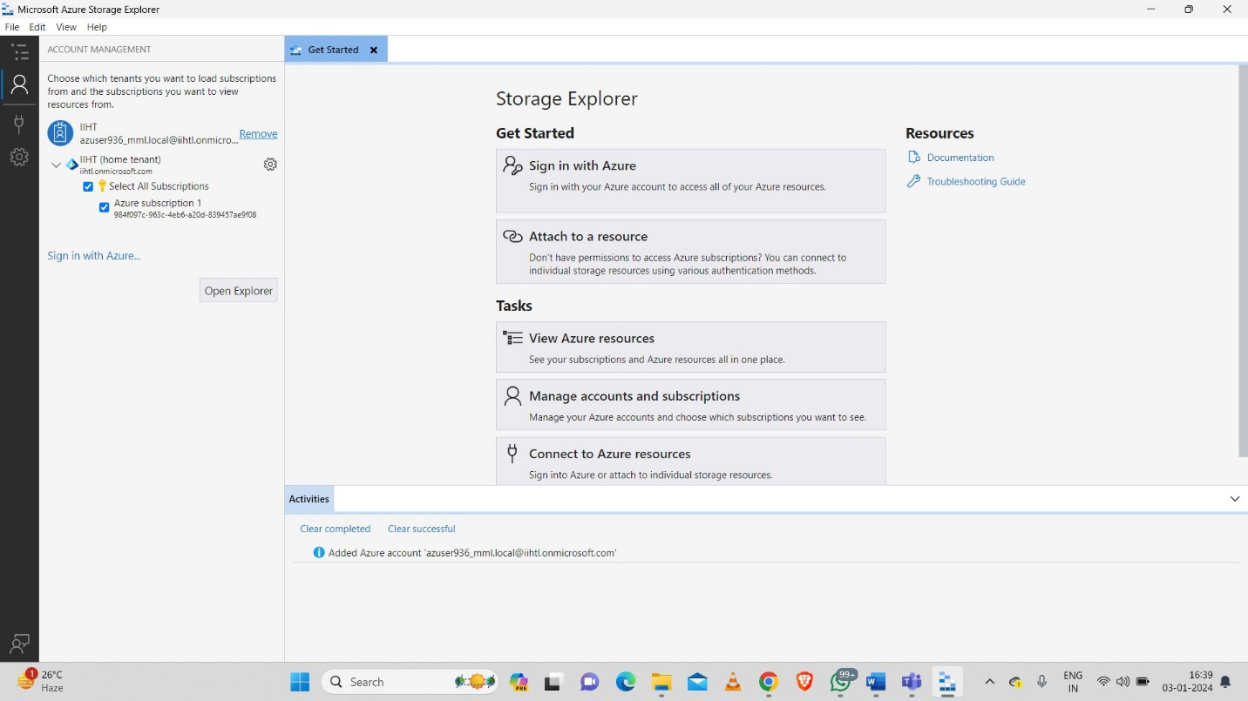

We need to search our storage account name in explorer.

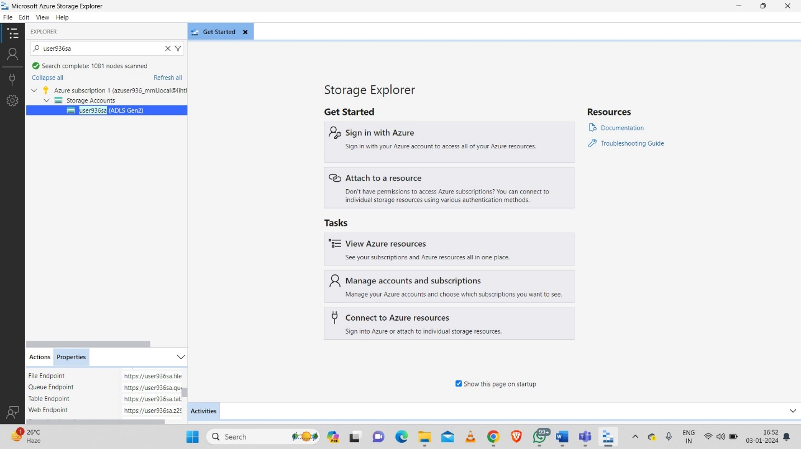

We need to copy the primary connection string from the below.

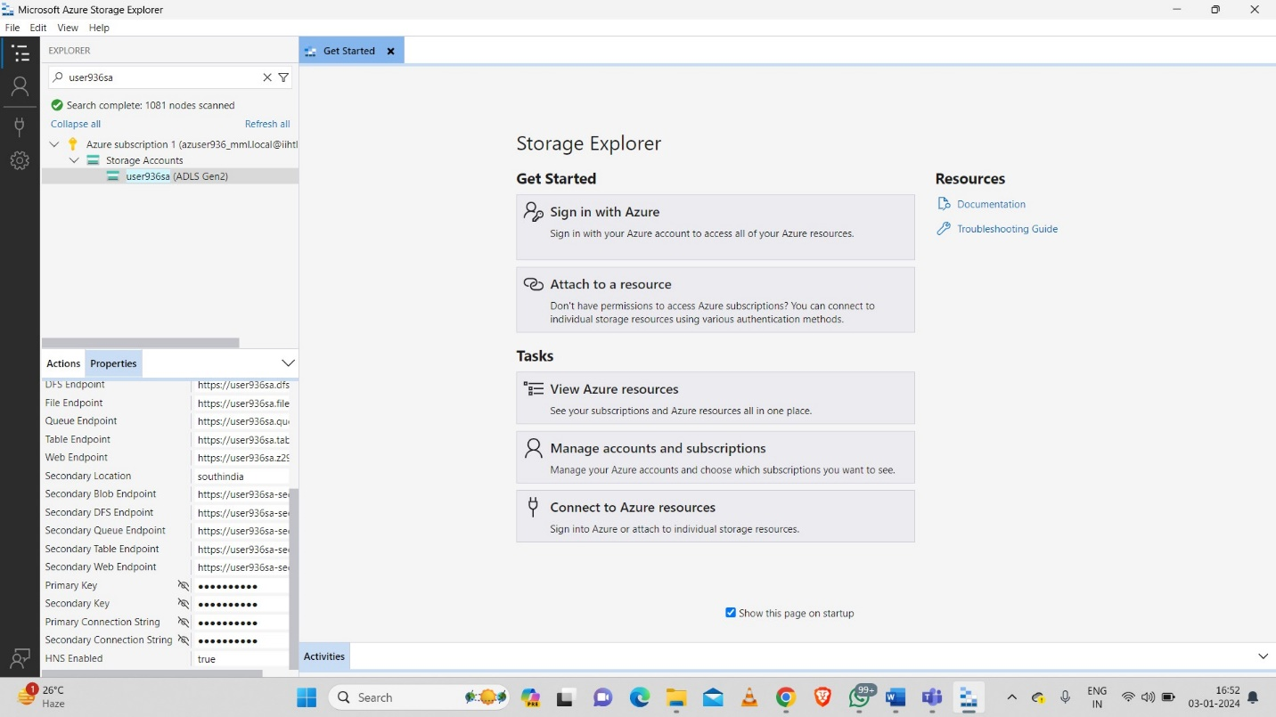

We need to connect to azure storage

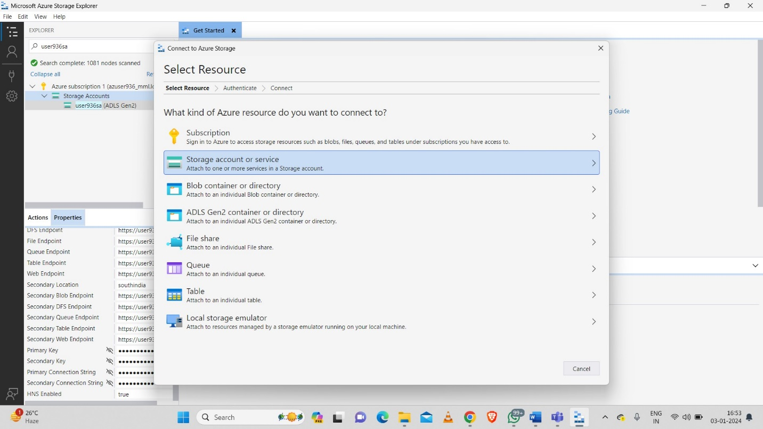

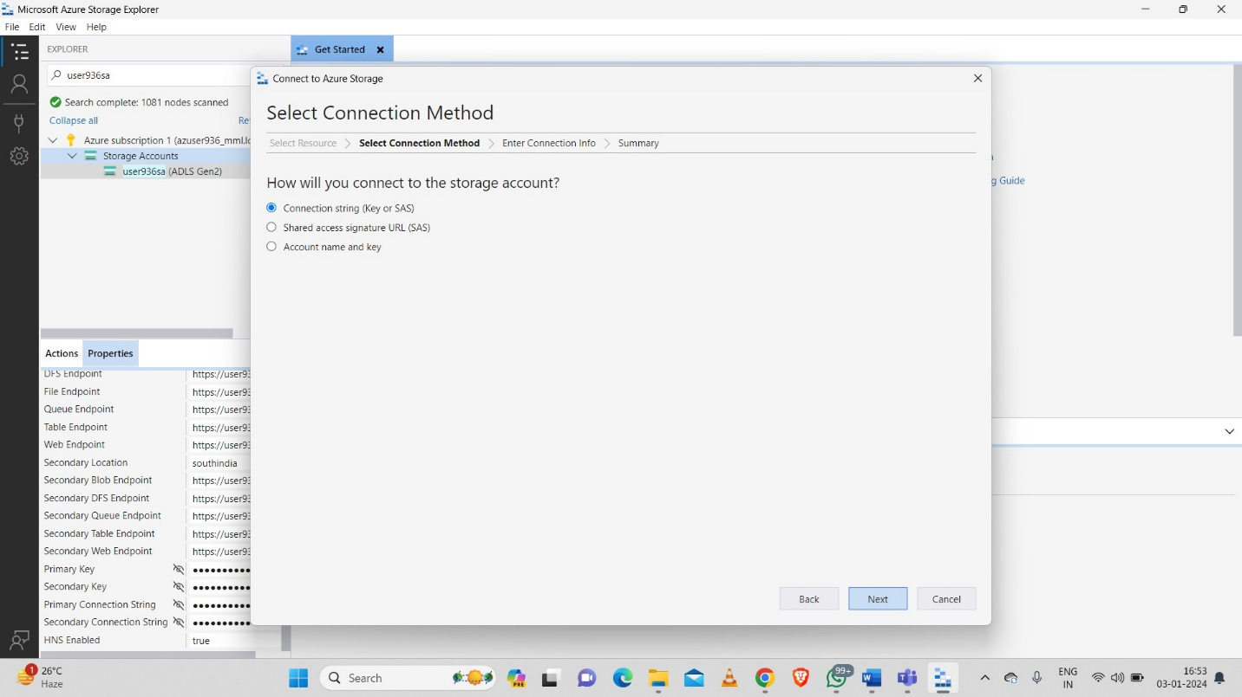

We need to give the copied connection string here.

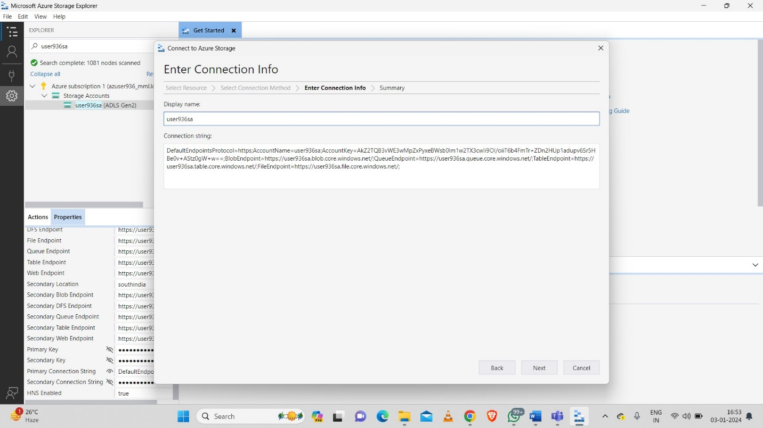

After clicking on next button we will get like new connection added successfully.

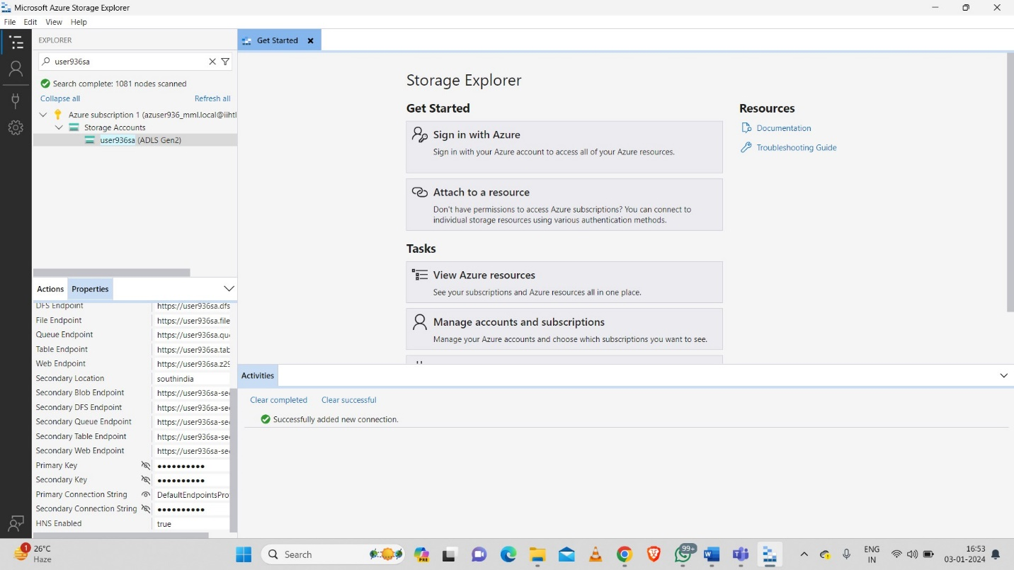

Then we need to open the blob container after establishing connection.

We can able to see the data which we uploaded in the container in azure portal.

